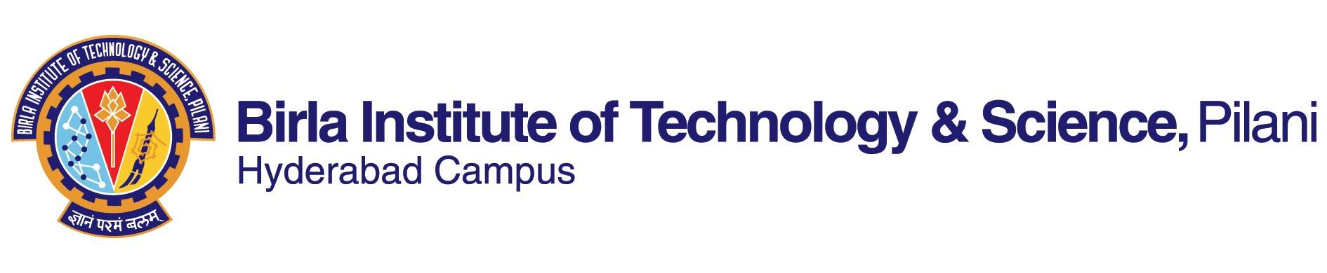

**SECOND SEMESTER 2022-23**

# Course Handout Part II

Date: 16-01-2023

In addition to part-I (General Handout for all courses appended to the time table) this portion gives further specific details regarding the course.

*Course No.* : CHE F412 Lecture: M,W, F 10-11 AM

## Course Title : PROCESS EQUIPMENT DESIGN Room no: F 204

## Instructor-in-Charge : Dr. Ramesh Adusumalli

1. **Scope and Objective of the Course**: This subject will enable students to use basics of applied science in the form of mechanics, strength of materials, and selection of materials to design equipment under certain operating conditions. In a broader view, it would help the students to understand the mechanical design of process equipment such as pressure vessel, support and calculation procedures for design of equipment like storage vessels, reactors, heat exchangers and distillation columns. It will help them to understand various design codes used for fabrication of these equipment’s and the various types of tests performed on equipment’s before and after assembly of equipment defining its capacity, reliability, and its life.
2. **Learning Outcomes:**
3. The students should be familiar with design aspects of equipment’s used in chemical industries. These aspects can be selection of materials, design of main body, flanges, gaskets and other components.
4. The students should have learnt aspects of material properties especially yield stress and corrosion allowance
5. Finally, the students should be skillful in handling the design aspects of new process equipment after coupling with learning outcomes of Process Design Principles-1 and -2.
6. **Textbooks:**
7. Joshi’s Process Equipment Design by V V Mahajani, SB Umarji, McMillan Publ. India Ltd, 2009

**Reference books**

1. Process Equipment Design by Shrikant Dawande. Denett & Co, Nagpur, 2009
2. Chemical Engineering Design. R.K. Sinnott, Vo1. 6, Ed 3 in J.M.Coulson, J.F.Richardson Chemical Engineering Series; Elsevier Butterworth – Heinemann publishers, 2000.
3. Process equipment design : Vessel design by Lloyd E. Brownell and Edwin H. Young; John Wiley 2004
4. **Course Plan:**

|  |  |  |  |
| --- | --- | --- | --- |
| **Lect. No.** | **Learning objectives** | **Topics to be covered** | **Chap. in the Text Book** |
| 1 | Introduction | Basic considerations in Process Equipment Design | 1 |
| 2-6 | Materials of Construction | Mechanical Properties, Materials of Construction (metals and nonmetals), Corrosion and its prevention, Choice of Materials including FRP | 2.1-2.4, notes |
| 7- 10 | Design Consideration | Stresses created due to static and dynamic loads, Design stress, Combined stresses and theories of failure, Fatigue, Creep, Temp. effects | 3.2, 3.3, 3.5-3.9 |
| 11-16 | Design of Pressure Vessels | Pressure vessel codes, Selection of Materials, Design conditions and stresses, Design of Shell and its components like Head, Nozzle, Flanges and Gaskets. Design of reinforcement. Numerical covering the above aspects. | 5.1-5.8 |
| 17 | Storage Vessel | Storage of volatile liquids, standard fixed roof storage tanks, Design of tanks, Wind Girders for open-top tanks | 7.1-7.7 |
| 17-20 | Design of Heat exchanger | Design of Shell and tube heat exchanger, tubes/tube sheet, Channel/channel cover and Nozzles. Numerical covering the above aspects. | 9.2-9.3 |
| 20-25 | Design of Distillation and absorption towers/columns | Basic features of towers, Process engineering data, Tower/column internals, Stresses in column shell, Determination of shell thickness. Numerical covering the above aspects. | 11.1-11.9 |
| 26-27 | Supports for Vessels | Bracket or Lug support, Leg Support, Skirt Support, Saddle Supports | 131.-13.5 |
| 28-31 | Design of Reaction Vessel | Heating systems, Jackets, Design of Vessel Shell with Channel jacket. Numerical covering the above aspects | 8.1-8.6 |
| 31-35 | Safety measures in Equipment design | Analysis of Hazards, Safety measures in Equipment design, Pressure relief devices | 17.3-17.6 |
| 36-37 | Process flow diagrams | Process block diagram, Process flow diagram, Piping and instrumentation diagram | 18.2-18.4 |
| 38-40 | Lab tour | Demonstration of equipment (Rotary digester, Distillation column Shell and tube heat exchanger, Supermass Colloider and Pressure vessel) |  |

1. **Evaluation Scheme:**

|  |  |  |  |  |
| --- | --- | --- | --- | --- |
| **Component** | **Duration** | **Weightage** | **Date & Time** | **Remarks** |
| Midterm | 90 min | 30% | 14/03 11.30 - 1.00PM | CB |
| Surprise tests1 |  | 15 % |  | OB |
| Seminars2 |  | 15 % |  | OB |
| Comprehensive Exam. | 3 hours | 40 % | 10/05 AN | OB (1.5 hr, 20%) + CB (20%) |

1Total three surprise tests will be conducted. Best two will be taken for 15 % weightage.

2Seminar topics will be given for those who maintains 50 % attendance.

**7**. **Chamber Consultation Hour:** To be announced later. **(Chamber: D 207)**

**8**. **Notice:** Notice will be displayed on CMS

**9. Make-up policy**: Make-up will be granted after he /she maintains minimum 50 % attendance in the class. Certificate from authenticated doctor from the Medical Center must accompany make-up application and follow the guidelines for midterm and compre exams.

**Academic Honesty and Integrity Policy:** Academic honesty and integrity are to be maintained by all the students throughout the semester and no type of academic dishonesty is acceptable.

**Dr. Ramesh Adusumalli**

**INSTRUCTOR-IN-CHARGE**